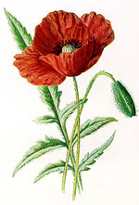

Anzac Day – April 25

On Anzac Day we will be attending the Dawn Service at Simpson Barracks and later will be participating in the Greensborough Anzac Day March (this is the one attended by most Banyule District Scout Groups). FULL Uniform to be worn (white scarf for New Chums!). If you can’t make it to the Dawn Service, please try to get to the March later on.

Dawn Service

The Service starts 6.00am Sharp at Simpson Barracks – assemble at 5:30 - enter off Yallambie Road (Melway 20 F6). You will be directed where to park (tons of cars!). Dress Warmly.
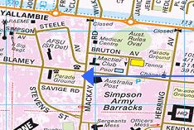
To try to keep the Group together (large crowd), families should try to meet at the corner of Blamey and Mackay Roads (see map) at 5:30am. If you don’t meet up with us there, continue on with your family and participate in the service!

Breakfast will be served in the Mess for around $4.00 afterwards. There may be a little wait for breakfast as this is packed each year.

March

We’re participating in the Greensborough march. Meet at the carpark off Poulter Ave (over the road from Greensborough RSL), Greensborough
- Melway Map 20 K1

Be there at 8.30am to get ready for the start.

The March will proceed up the hill to Memorial Park in Henry Street for the Anzac Service. Refreshments will be provided for the Cubs at Greensborough R.S.L. afterwards.

Remember: On top of the significance of Anzac Day for us, participation in at least one of the Services is also part of the Heritage Badge (‘Their Service, Our Heritage’). If you take part in another Anzac Day service (family tradition etc.), please let us know so your attendance can still count.

Regards


The Leaders
Wayne (Akela), Laura (Chil) and David (Bagheera)
Contact: 9434 7594
akela@rosannacubs.org

see us at www.rosannacubs.org

